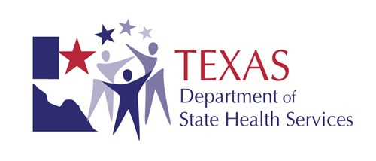

AGENDA
TOBACCO SETTLEMENT PERMANENT TRUST ACCOUNT
ADMINISTRATION ADVISORY COMMITTEE MEETING
THURSDAY, NOVEMBER 5, 2015, 1:30 p.m.
Texas Department of State Health Services (DSHS)
1100 West 49th Street, Austin, Texas
*Conference Room G-103*

*Teleconference Access*
Please dial 877.820.7831 and enter participant passcode: 423598#
Note: the pound key [#] must be entered after the participant passcode

Welcome and Call to Order King Hillier, Chairman

Roll Call Elaine McHard, DSHS

Introduction of New Members (Tab 2) King Hillier, Chairman

Approval of October 22, 2014 Meeting Minutes (Tab 3) King Hillier, Chairman

Review of 2015 Distribution (Tab 4) Elaine McHard, DSHS

Review of 2015 Audits (Tab 5) Elaine McHard, DSHS

Approval of Proposed Program Rule Changes-25 TAC 102 King Hillier, Chairman
(Tab 6)

Old/New Business, Date of next annual meeting (Tab 7) Elaine McHard, DSHS

Adjourn King Hillier, Chairman

Membership: Jerry Bearden Honorable David Bird
Betsy Briscoe Keri Disney-Story
Honorable Woodrow Gossom R. King Hillier
Jonny Hipp Carolyn Konecny
Michael Nunez Eddie Olivarez
Honorable Darryl Primo

