This test document to be used for testing only – Baha. Bahrom. bkasimov

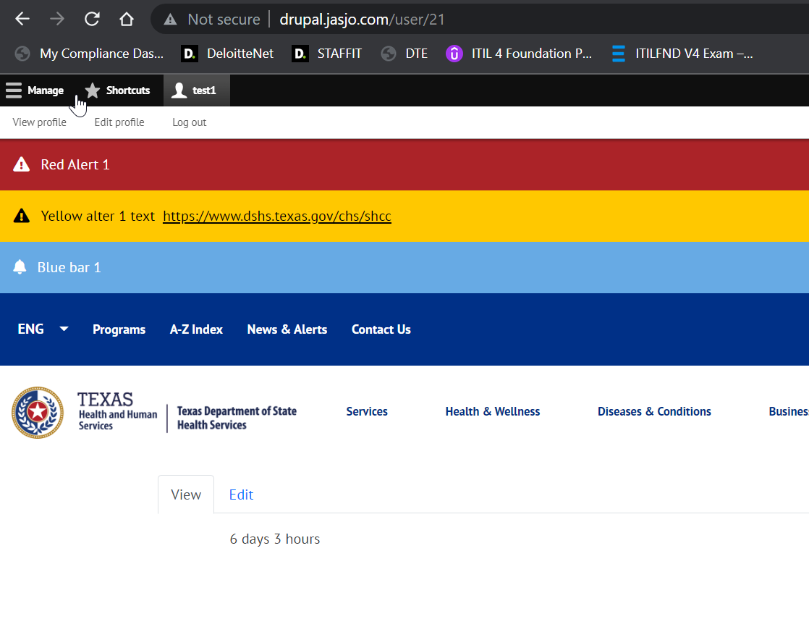





















Test test for this file.

