This test document to be used for testing only – Baha. Bahrom. bkasimov

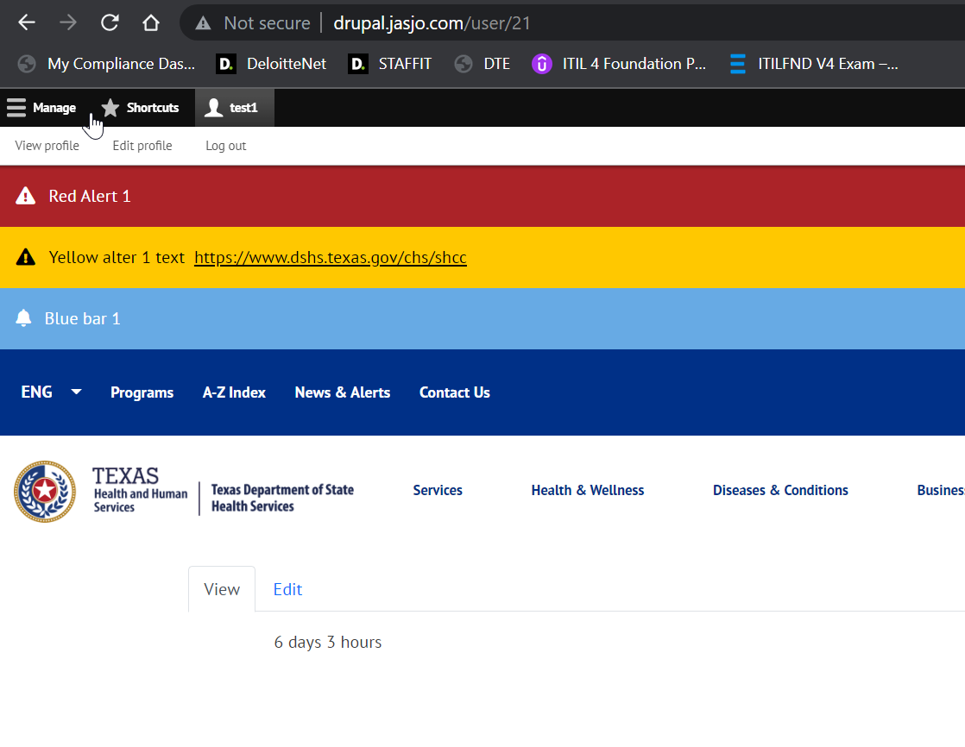

Test test for this file.

